**PC Lint**

Contents

1 Lint file. 2

1.1 ***.hpp file not found? 2

1.2 Add **digitalOutput** option. (Copy digitalInput option, then change path.) 2

1.3 **Select** digitalOutput.cpp file (Lint file menu.) 2

1.4 Correct by MISRA standard. 3

2 Project Lint. 4

2.1 Run Prject-lint. 4

1. Lint file.

## ***.hpp file not found?

**#include** "torqueLimiterConfig.hpp" put in ***imp.hpp.

/SwingDoorPlatform/lint/conf/gcc-include-path.lnt

## Add **digitalOutput** option. (Copy digitalInput option, then change path.)

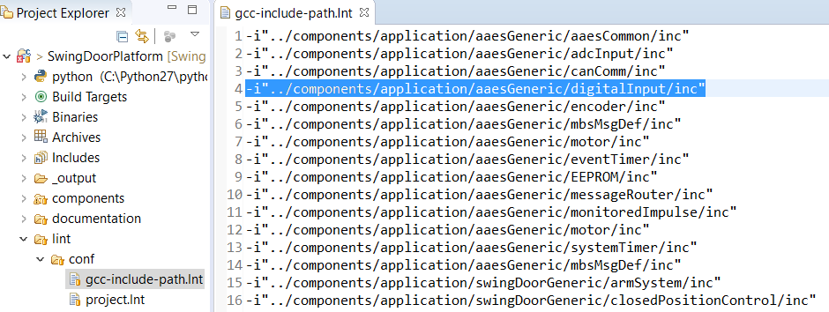

## **Select** digitalOutput.cpp file (Lint file menu.)

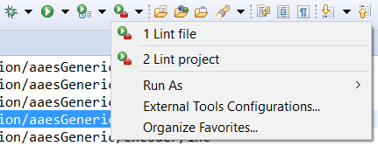

## Correct by MISRA standard.

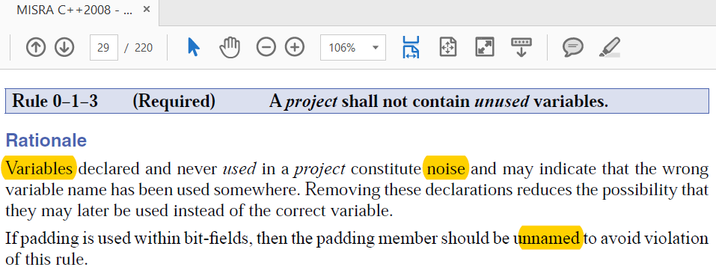

1. Project Lint.

/SwingDoorPlatform/lint/conf/project.lnt

..\components\application\aaesGeneric\torqueLimiter\src\torqueLimiter.cpp

## Run Prject-lint.

